INTRODUCTION TO WEB DEVELOPMENT
ASSIGNMENT 1
QUESTION 1:
Explain the difference between frontend, backend, and full-stack development with suitable real-world examples.
ANSWER:
Web development is mainly divided into frontend, backend, and full-stack development.
Frontend Development:
Frontend development is the part of a website that users can see and interact with. It includes the layout, buttons, menus, forms, images, and other visible elements. HTML, CSS, and JavaScript are commonly used for frontend development.
Example: In an online shopping website, the product images, search bar, navigation menu, product pages, and shopping cart interface are part of the frontend.
Backend Development:
Backend development deals with the server-side part of a website. It handles business logic, user authentication, data processing, and communication with databases. Common backend technologies include Python, Java, Node.js, PHP, and C#.
Example: When a customer places an order on an online shopping website, the backend processes the order and stores the order details in the database.
Full-Stack Development:
Full-stack development involves both frontend and backend development. A full-stack developer can work on the user interface, server-side logic, APIs, and database.
Example: A developer who creates the complete frontend, backend, APIs, and database of an online shopping website is a full-stack developer.
In simple words:
Frontend = What the user sees and interacts with.
Backend = What happens behind the scenes.
Full-Stack = Frontend + Backend.
QUESTION 2:
Create a simple diagram showing how the client-server model works in web architecture.
ANSWER:
The client-server model is a system in which a client sends a request to a server, and the server processes the request and sends a response back to the client.
DIAGRAM:
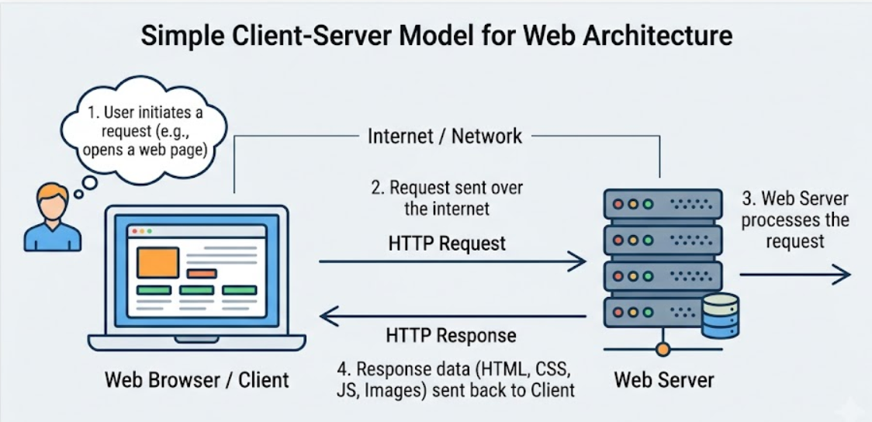
Example:
When a user opens an online shopping website, the browser acts as the client. It sends a request to the server. The server processes the request and may retrieve information from the database. The server then sends the required information back to the browser.
QUESTION 3:
Describe how a browser requests and displays a web page from a web server.
ANSWER:
When a user enters a website address in a browser, several steps take place before the webpage appears on the screen.
- The user enters a URL such as https://example.com.
- The browser performs a DNS lookup to find the IP address of the server.
- The browser establishes a connection with the web server.
- The browser sends an HTTP or HTTPS request to the server.
- The server processes the request. It may access files, run backend code, communicate with a database, or use an API.
- The server sends a response containing HTML, CSS, JavaScript, images, or other required files.
- The browser processes the HTML and creates the structure of the webpage.
- The browser loads CSS and JavaScript.
- The browser renders the webpage.
- Finally, the webpage is displayed on the user's screen.
QUESTION 4:
Identify and list the tools required to set up a web development environment. Explain the purpose of each.
ANSWER:
A web development environment requires different tools for writing, testing, running, and managing websites.
- Visual Studio Code (VS Code):
It is a source-code editor used to write and manage HTML, CSS, JavaScript, and other programming languages.
- Web Browser:
Examples include Google Chrome, Microsoft Edge, and Mozilla Firefox. A browser is used to run, test, and view webpages.
- HTML:
HTML is used to create the basic structure and content of a webpage.
- CSS:
CSS is used to control the appearance and layout of a webpage, including colors, fonts, spacing, and positioning.
- JavaScript:
JavaScript is used to add functionality, logic, and interaction to webpages.
- Node.js:
Node.js allows JavaScript to run outside the browser and is commonly used for backend development and development tools.
- Git:
Git is a version control system used to track changes made to a project.
- GitHub:
GitHub is an online platform used to store code repositories and collaborate with other developers.
- Database:
Databases such as MySQL, PostgreSQL, and MongoDB are used to store and manage application data.
- Terminal or PowerShell:
A terminal is used to run commands, install packages, start development servers, and perform other development tasks.
QUESTION 5:
Explain what a web server is and give examples of commonly used servers.
ANSWER:
A web server is a computer system or software that receives requests from web browsers and sends the requested webpages or other resources back to them.
For example, when a user opens a website, the browser sends a request to the web server. The web server processes the request and sends the required files or information back to the browser.
A web server can provide resources such as HTML files, CSS files, JavaScript files, images, videos, and documents.
Some commonly used web servers are:
- Apache HTTP Server
- Nginx
- Microsoft IIS
- LiteSpeed
- Caddy
QUESTION 6:
Define the roles of a frontend developer, backend developer, and database administrator in a project.
ANSWER:
- Frontend Developer:
A frontend developer creates the part of a website that users see and interact with.
Main responsibilities:
- Creating webpages
- Designing user interfaces
- Making websites responsive
- Adding interactive features
- Connecting the frontend with APIs
- Testing websites on different browsers
Common technologies include HTML, CSS, JavaScript, React, Angular, and Vue.js.
- Backend Developer:
A backend developer works on the server-side part of an application.
Main responsibilities:
- Creating server-side applications
- Developing APIs
- Implementing login and authentication
- Handling business logic
- Connecting applications with databases
- Managing security and validation
Common technologies include Python, Java, Node.js, PHP, and C#.
- Database Administrator:
A Database Administrator, or DBA, is responsible for managing and maintaining databases.
Main responsibilities:
- Creating and managing databases
- Managing tables and records
- Managing database users and permissions
- Taking backups
- Restoring data
- Improving database performance
- Maintaining database security
QUESTION 7:
Install VS Code and configure it for HTML, CSS, and JavaScript development. Take a screenshot of the setup.
ANSWER:
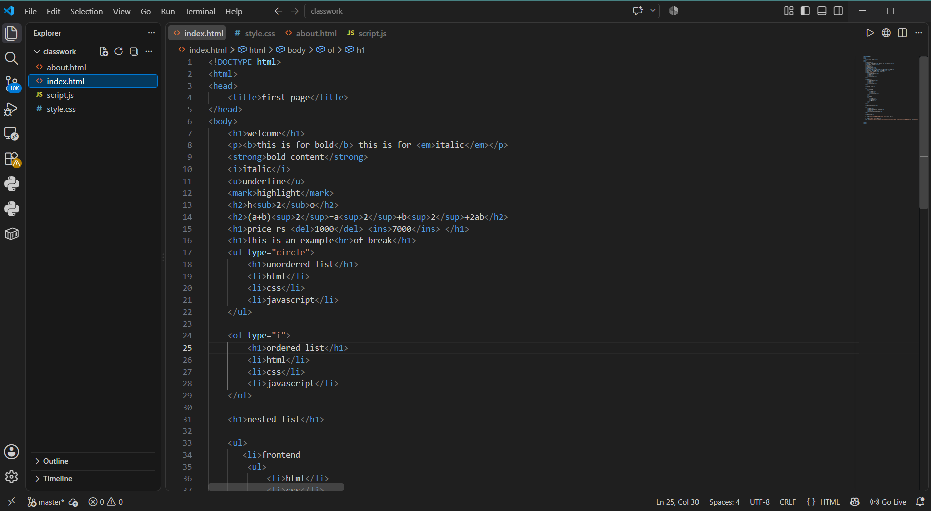
QUESTION 8:
Explain the difference between static and dynamic websites. Provide an example of each.
ANSWER:
Static Website:
A static website is a website where the content remains mostly fixed. The content changes only when the developer manually modifies the webpage files.
Features:
- Simple structure
- Fast loading
- Easy to host
- Usually does not require a database
- Content is mostly fixed
Example:
A personal portfolio website containing Home, About, Skills, Projects, and Contact pages can be a static website.
Dynamic Website:
A dynamic website is a website where the content can change depending on the user, database, input, or other conditions.
Features:
- Interactive
- Content can change automatically
- Usually uses a database
- Can have user accounts
- Often uses backend programming
Example:
An online shopping website is a dynamic website because products, user accounts, shopping carts, orders, and recommendations can change according to the user and database information.
QUESTION 9:
Research and list five web browsers. Explain how rendering engines differ between them.
ANSWER:
A browser rendering engine is the component that interprets HTML and CSS and converts them into the webpage displayed on the screen.
- Google Chrome
Rendering Engine: Blink
Google Chrome is developed by Google and is one of the most widely used web browsers.
- Microsoft Edge
Rendering Engine: Blink
Modern Microsoft Edge is based on Chromium and uses the Blink rendering engine.
- Mozilla Firefox
Rendering Engine: Gecko
Firefox is developed by Mozilla and uses the Gecko rendering engine.
- Apple Safari
Rendering Engine: WebKit
Safari is developed by Apple and uses the WebKit rendering engine.
- Opera
Rendering Engine: Blink
Modern Opera is based on Chromium and uses the Blink rendering engine.
Browser and Rendering Engine:
Google Chrome - Blink
Microsoft Edge - Blink
Mozilla Firefox - Gecko
Apple Safari - WebKit
Opera - Blink
Different rendering engines may process certain web features differently. Therefore, developers test their websites in different browsers to make sure the website works correctly across different platforms.
QUESTION 10:
Draw a labeled diagram showing the basic web architecture flow — client, server, database, and APIs.
ANSWER:
A basic web application consists of several components that work together. The client is usually the user's browser or mobile application. The server processes requests and contains the application logic. APIs allow different software components to communicate, while the database stores application data.
DIAGRAM:
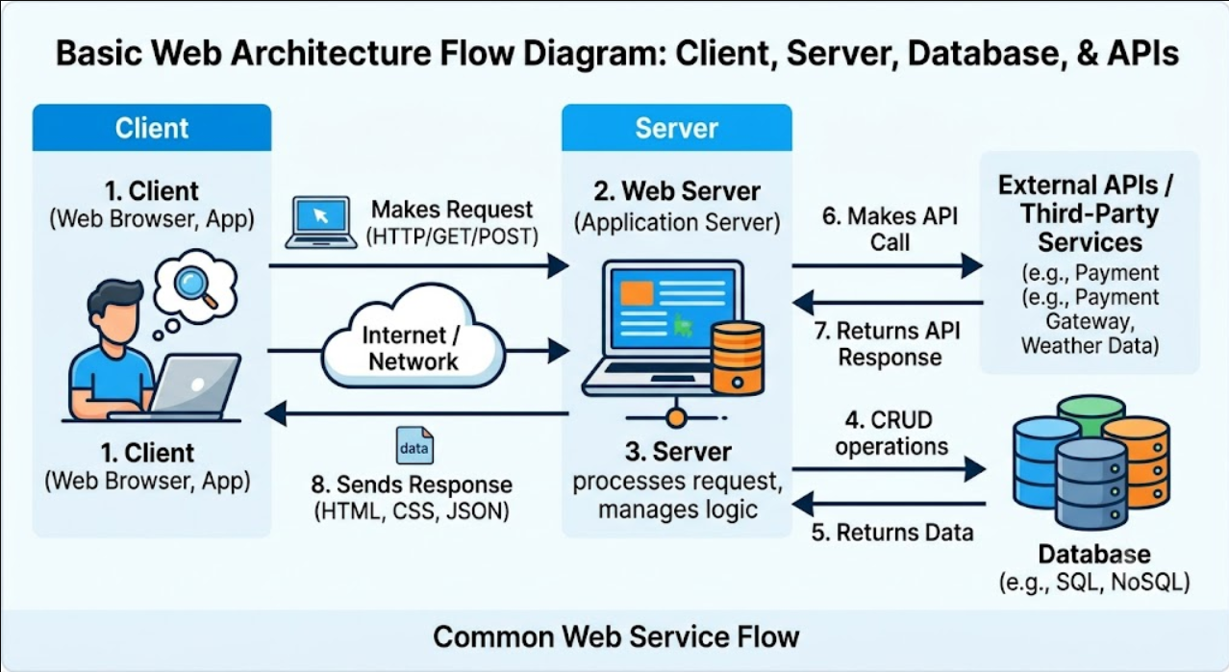
Example:
Suppose a user searches for a product on an online shopping website. The user enters the search term in the browser. The frontend sends a request to the backend through an API. The backend communicates with the database and retrieves the required product information. The information is then sent back to the frontend, where it is displayed to the user.
Overall Flow:
Client -> Frontend -> API -> Backend -> Database
Database -> Backend -> API Response -> Frontend -> Client

